Literature Review

1. Introduction
Blockchain technology has emerged as a transformative solution for secure and decentralized financial systems. Traditional financial infrastructures often rely on centralized authorities that maintain control over transaction validation, which may introduce risks related to fraud, manipulation, and lack of transparency. Blockchain introduces a distributed ledger that records transactions in an immutable and verifiable manner across multiple nodes. This architecture eliminates the need for intermediaries while ensuring transparency and trust among participants. Recent studies highlight that decentralized finance (DeFi) platforms leverage blockchain and smart contracts to automate financial operations such as lending, borrowing, and asset exchange without requiring centralized control [1], [2].
The concept of decentralized applications (DApps) has further expanded the possibilities of blockchain adoption in financial services. These applications use smart contracts to enforce predefined rules and automate transactions between parties in a secure and transparent environment. Research indicates that smart contracts are capable of executing agreements automatically when specific conditions are met, thereby reducing operational overhead and increasing efficiency in financial ecosystems [3].
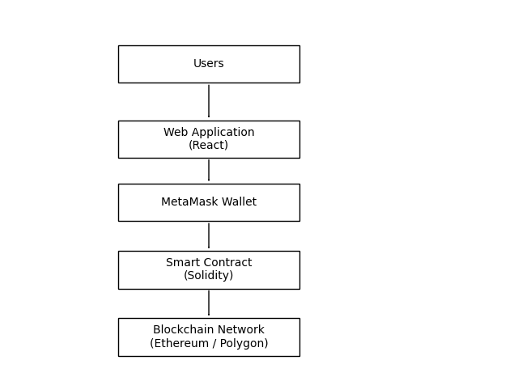

This figure illustrates the layered architecture of the proposed decentralized lending system. The architecture consists of four main components: users, the web application interface, wallet authentication, and the blockchain network. Users interact with the system through a React-based web interface, which connects to the MetaMask wallet for secure transaction signing. The wallet communicates with the Solidity smart contract deployed on the Ethereum blockchain. All financial operations such as group joining, loan release, EMI repayment, and profit distribution are executed through the smart contract and permanently recorded on the blockchain ledger.

2. Problem Statement
Despite the advancement of fintech platforms, many community-based financial systems such as rotating savings and credit associations (ROSCA) and informal lending groups still rely on manual record keeping and interpersonal trust. These systems are vulnerable to fraud, delayed repayments, and lack of transparency in financial records. Studies have shown that traditional peer-to-peer lending models face challenges related to trust management, data security, and credit verification [4].
Furthermore, centralized financial platforms require users to trust the platform operators, which introduces potential risks such as data manipulation and misuse of financial information. Research on decentralized finance indicates that blockchain technology can address these challenges by ensuring transparent, tamper-proof, and automated financial transactions [5]. However, most DeFi systems focus primarily on speculative cryptocurrency trading rather than structured community lending mechanisms.

3. Proposed Solution
To overcome these limitations, blockchain-based lending systems have been proposed that utilize smart contracts to automate financial agreements and enforce repayment schedules. Such systems enable transparent financial management by recording all transactions on a distributed ledger. Recent studies demonstrate that blockchain-based lending platforms can support microfinance initiatives and enhance financial inclusion by reducing transaction costs and improving governance mechanisms [6].
In addition, blockchain-enabled peer-to-peer lending models allow participants to interact directly without relying on traditional intermediaries such as banks. This decentralized approach improves trust and transparency while enabling automated monitoring of loan transactions [7]. The proposed system, BlockChit, builds upon these concepts by integrating community lending structures with blockchain-based smart contracts.
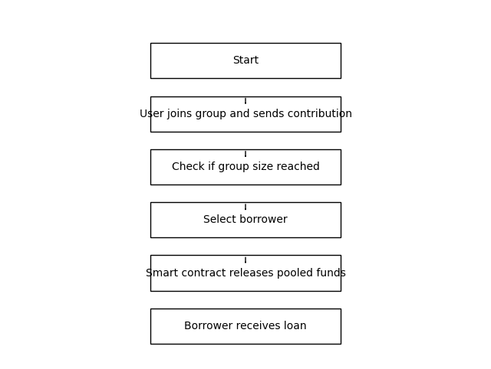
The contribution workflow begins when users join the lending group by depositing a predefined contribution amount. Once the required group size is reached, the smart contract allows borrower selection based on predefined rules. After confirmation, the pooled funds are automatically transferred to the borrower’s wallet address. This automated mechanism ensures transparent and rule-based financial execution without relying on centralized authorities.

4. Algorithms and Techniques
Several algorithms and computational mechanisms have been proposed in blockchain-based lending research. Smart contract execution algorithms allow automated validation of transaction conditions before funds are transferred. Time-based execution algorithms ensure scheduled repayments and prevent premature withdrawals. Research also highlights the importance of consensus algorithms that maintain the integrity and synchronization of distributed ledgers across the network [8].
Additionally, decentralized lending protocols often implement credit-scoring and risk-evaluation models to assess borrower credibility. Studies suggest that integrating data-driven analytics with blockchain records can improve loan governance and reduce financial risks in decentralized ecosystems [9].
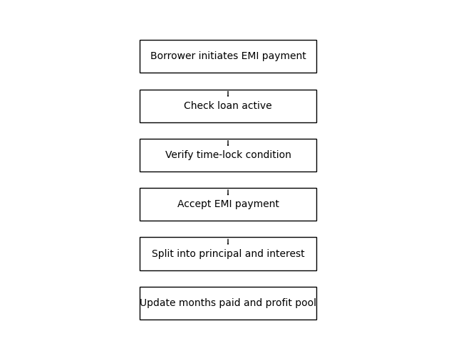
The EMI repayment algorithm enforces automated loan repayment through smart contract logic. The algorithm verifies whether the borrower is authorized and whether the repayment interval condition has been satisfied. If the conditions are met, the borrower submits the EMI payment. The smart contract then separates the payment into principal and interest components. The interest amount is accumulated in a profit pool for later distribution among members, while the principal contributes to loan repayment. The system updates the repayment count and records the transaction on the blockchain.

5. Outcomes of Existing Research
Existing literature demonstrates that blockchain-enabled financial systems can significantly improve transparency, reduce operational costs, and eliminate the need for intermediaries. Empirical studies of decentralized lending platforms reveal that smart contracts can automate complex financial operations while maintaining verifiable audit trails [10]. Moreover, blockchain technology has been shown to enhance financial inclusion by enabling secure peer-to-peer lending among individuals who lack access to formal banking services [6].

6. Applications
Blockchain-based financial systems have been applied in multiple sectors, including peer-to-peer lending, microfinance, supply-chain financing, and decentralized banking. These systems allow organizations to track financial transactions in real time while ensuring transparency and security. Research indicates that blockchain technology can also support governance systems, public financial records, and cross-border financial services by providing a tamper-proof ledger infrastructure [2].

7. Future Scope
Although blockchain-based financial systems show promising potential, several research challenges remain. Future work may focus on scalability improvements, integration of off-chain data sources through blockchain oracles, and enhanced privacy mechanisms for financial transactions. Advanced credit-scoring algorithms and machine learning models could further improve borrower evaluation in decentralized lending ecosystems. Researchers also emphasize the need for regulatory frameworks and interoperability standards to support large-scale adoption of blockchain-based financial services [5].

References
[1] P. K. Ozili, “Decentralized finance research and developments around the world,” Journal of Banking and Financial Technology, 2022.
[2] M. Javaid et al., “Blockchain technology applications in financial services,” ScienceDirect, 2022.
[3] M. Alharby and A. van Moorsel, “Blockchain-based smart contracts: A systematic mapping study,” arXiv, 2017.
[4] K. Saengchote, “Decentralized lending and its users: Insights from Compound,” Finance Research Letters, 2023.
[5] A. Ali, “Decentralized finance and its impact on traditional banking systems,” SSRN, 2024.
[6] A. Sharma et al., “TruChit: A Blockchain-Based Trusted Chit Fund System,” Procedia Computer Science, 2024.
[7] S. Wang, “Blockchain-enabled peer-to-peer finance platforms,” SSRN, 2023.
[8] F. Zhu et al., “A lending scheme based on smart contracts for banks,” ITM Web of Conferences, 2022.
[9] T. Tanchangya et al., “Mapping blockchain applications in fintech: A systematic review,” Information, 2025.
[10] “Blockchain-based peer-to-peer decentralized lending and borrowing system,” International Journal for Research in Applied Science & Engineering Technology.

